Assessment 8

* 1. Write a Query to fetch all Open Status claims.

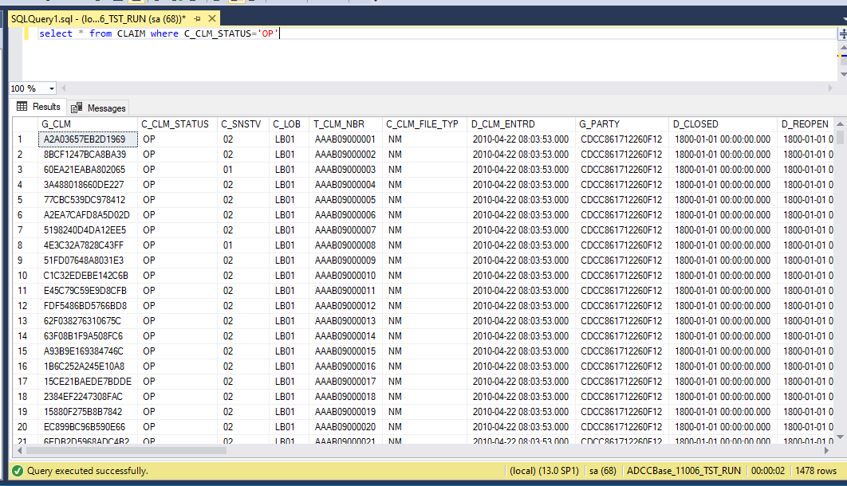

1. List Payment details for CLAIM “ DM4211000034”.

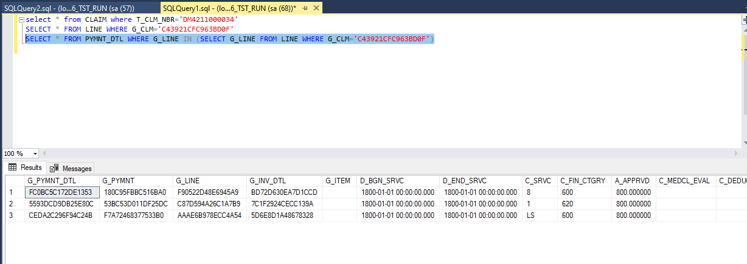

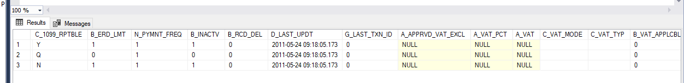

1. List the Property LOB claims

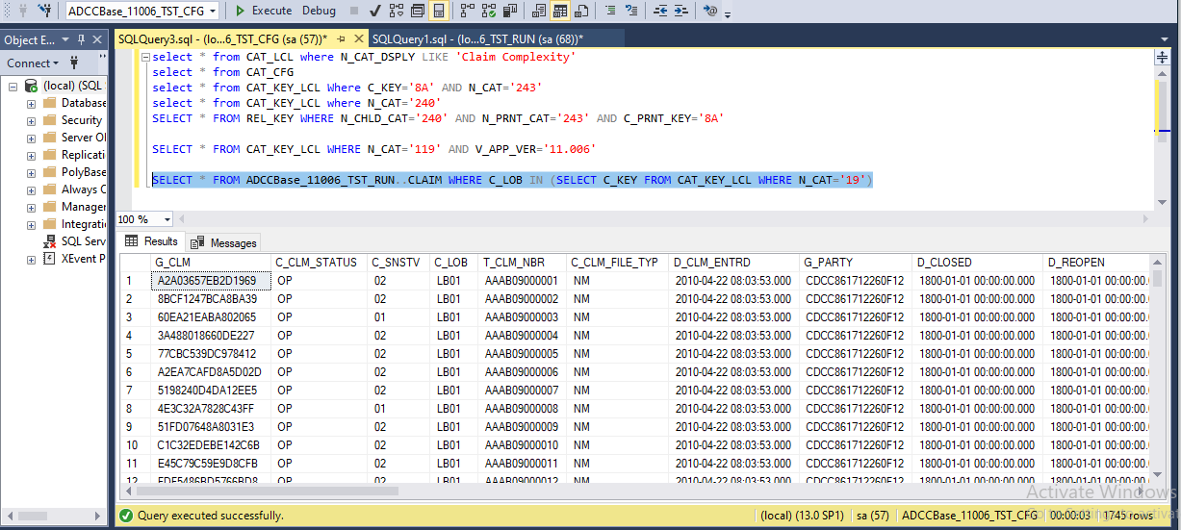

1. Open claim having open lines

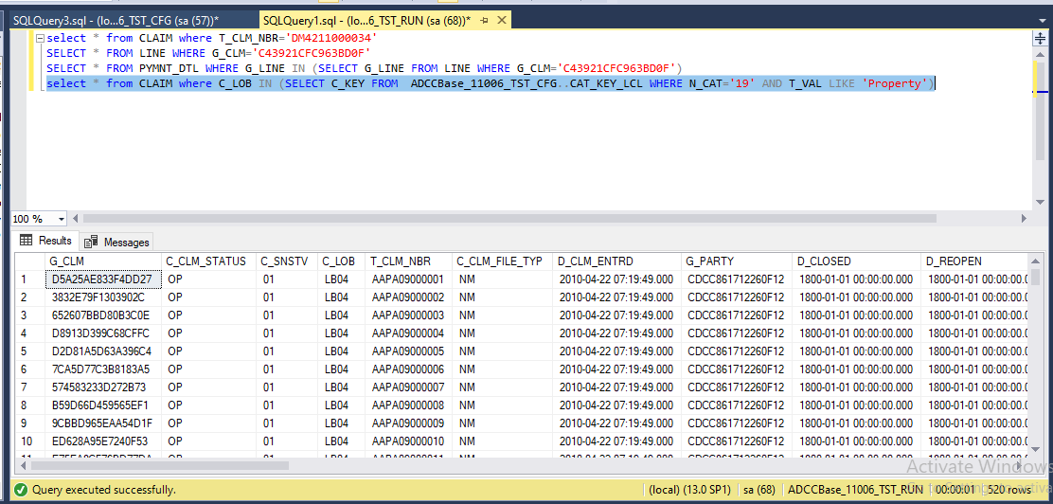

2.1. List all the available LOB values in Claims.

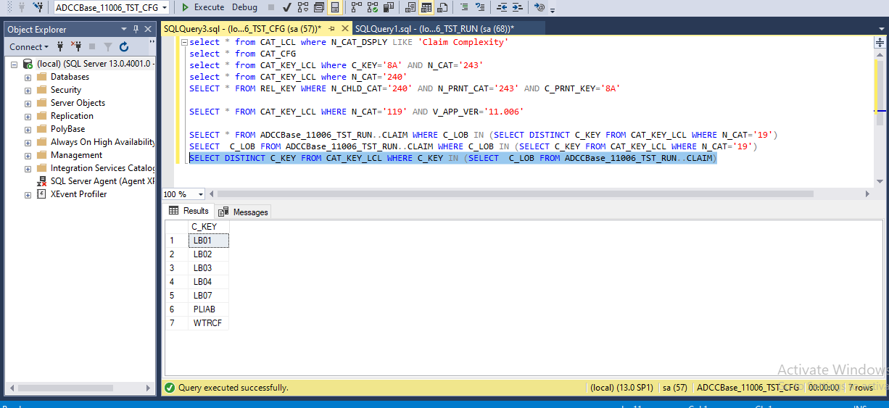

2.2. Open the any of the rule you had created during Console use cases

Show the EXTPT_ACTN, RLE_LCL, RLE_ACTY_INST table data for this rule.

You can use the extension point name/rule name and query respective LCL tables and check N_RLE_DSPLY or N_EXTPT_DSPLY.

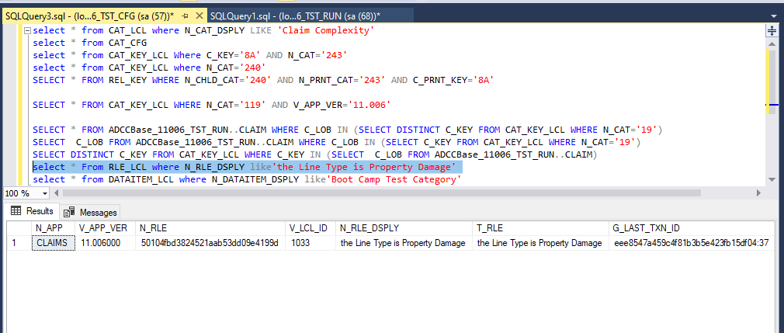

2.3 .Query all the tables as you can remember to check show some of the impacted tables.

Using the attached script for HA_Demo

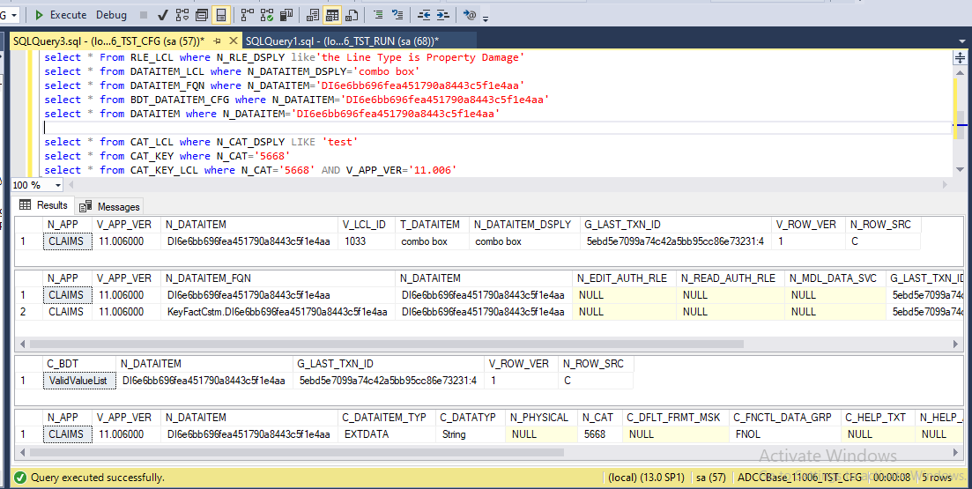

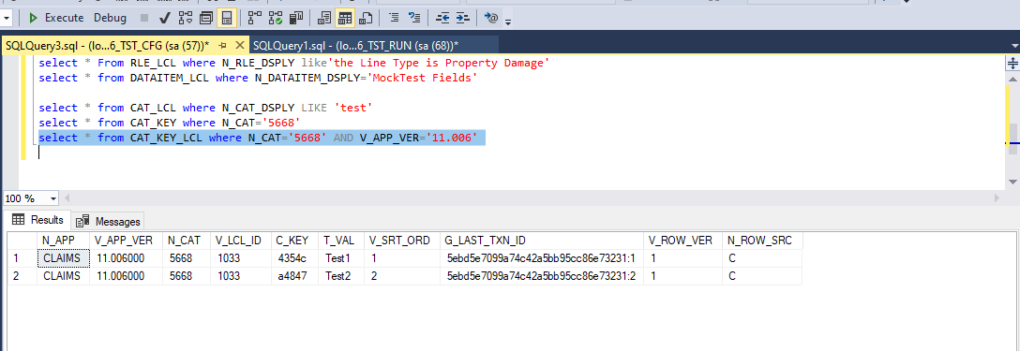

2.4

